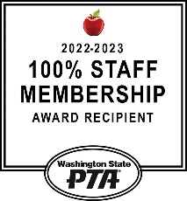
December Maple Hills PTA Newsletter

Welcome to Winter
The Chirp!
Important Dates

December 11th – 14th
Tutta Bella Fundraiser
December 12th
Eagle Reader Clubhouse
December 15th
Student Council Meeting
December 18th – January 1st Winter Break – No School
January 17th
Variety Show Auditions!
January 23rd
PTA General Membership Meeting
February 9th
Variety Show
The Maple Hills Elementary PTA has partnered with Tutta Bella to raise funds for our organization and the programs we support at
Maple Hills Elementary!
To participate it is as Easy As Pie! 20% of your order will be donated to the Maple Hills Elementary PTA!
Order Sunday, December 10th – Thursday December 14th (Dine In or Place an online order at tuttabella.com for delivery, takeout or curbside pickup).
Use code:EasyAsPieMapleHills when you checkout online or in the restaurant.
See the full details at the Maple Hills PTA Website!

Dear Maple Hills Families,
We hope this newsletter finds you well and thriving as we embrace the autumn season. December is upon us, and our PTA has been working diligently to bring a sense of belonging and purpose to our school community (see 2023-2024 Mission Statement and Goals).
In the spirit of community, October was a busy month for the PTA and our volunteers. We kicked off our Watch D.O.G.S. program with Donuts with Watch D.O.G.S., hosted an Author Visit, and celebrated back to school with our Fall Celebration, thank you to everyone who signed up to volunteer to make these events a success!
Additionally, we held our first General Membership Meeting of the 2023-2024 school year, where we discussed the annual budget, approved our Mission Statement and Standing Rules, and highlighted all the amazing work being done around the school.
~Maple Hills PTA
2023 – 2024 Maple Hills PTA Financials
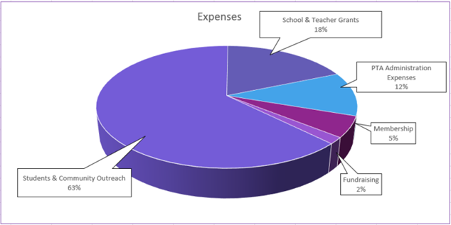

Recap as of 10/16/2023
Net income -$26,775 (Budget -$33,855)
Statement Balance: $95,229.10
Notable Movement:
Popcorn Friday Income: 2,393.00
Classroom Enrichment spend: $1,523.98

Winter Gift Giving Drive  Thank you to our incredible community and families, noted below for your generous donations to the Family Winter Gift Drive! Your kindness will bring joy and warmth to those in need. We are grateful for your compassion and support.  Wood, Stanley, Ozer, Purugganan, Friend, Young, Liu, Gumm, Wehmeyer, Tapper, Young, Warner, Willert, Oster, Sussman, Lapinsky, Campbell, Gauvey, Anderson, Moore, St. Pierre, Wieringa, Sanford, Christensen, Johnson, Nelson, Hirayu, Bryant, Tran, Brunell, Perrigo, Boyd, Howe, Walton, Mason, Shaughnessy, Santos-Lowry, Rose, Cullens, Meredith, Hampton, Richardson, Lecoq, Sloan, Simington, Angeles, Nugent, Nagaichouk, Roy, Ubaldo, Hampton, Freeberg, Oosterhof.  Please visit the PTA Website for more information. |  | Give the gift of PTA membership to family or friends and support the elementary school in a  meaningful way.  This year we have 455 Students at  Maple Hills Elementary.  We are currently at 87% membership.  We want to achieve a 1:1 ratio membership again this year. This means that there is 1 PTA Member for each student!  Scan the QR Code to  Renew or Sign Up  Already a member?  Friends and Family can join too!  Maple Hills PTA has achieved 100%  for the last 23 years!

Popcorn Friday Volunteers Needed!
Scan the QR Code to sign up!
We LOVE our Maple Hills Volunteers!
If you want to volunteer and cannot for a specific event or you don’t have time to volunteer regularly or chair a committee, fear not!
We have a new way to volunteer with the “Volunteers As Needed”.
Sign up here at Volunteer Central
Email: Communications@MapleHillsPTA.com to sign up for the PTA eNews

Remember to update your students Eagle Reader minutes.
Students will earn a free book the following month.
How to Participate:
Your student's minutes can be recorded online at: https://maplehillspta.com/Read/eaglereader
or scan the QR code below.
The Eagle Reader Program is sponsored by the
Maple Hills PTA.

Stay in the know with our weekly emails via our E-News. It includes important dates, events, and school programs, and more.

